School Communication
E-BLAST or NEWSLETTER Suggestions - November
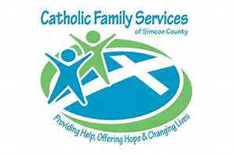
One of the agencies funded through ShareLife is the Catholic Family Services of Simcoe County which provides walk-in counselling clinics. These clinics offer single-session counselling for individuals, couples and families.
Services are available to everyone living or working in Simcoe County regardless of age, ability cultural or religious background, race, sexual orientation or gender identity. No appointment is necessary. If you are experiencing issues such as family conflict, stress, grief, depression, anxiety, relationship issues, separation, divorce or abuse contact Catholic Family Services of Simcoe County 1-888-726-2503.
We are excited to announce that our parish has subscribed to an exciting new online platform: Formed.org.
- 24/7 access to the truth, beauty and meaning of the Catholic Faith anytime, anywhere… with FORMED
- Use it on your computer, tablet or smartphone.
- Informative and inspiring teaching from renowned speakers Dr. Scott Hahn, Dr. Edward Sri, Bishop Robert Barron, Dr. Tim Gray, Father Michael Gaitley, Teresa Tomeo… and many more.
- Multiple programs to address multiple parish needs:
-Adult Faith Formation, Marriage Preparation and Enrichment, Scripture Study, RCIA, Sacrament Preparation, Small Group Teen Discipleship and much more!
Here’s how easy it is:
- Go to Formed.org
- Enter our PARISH CODE (2K8FFT) on the homepage
- Create a personal account with your user name/email and password
- Start enjoying the best Catholic content all in one place!
IMPORTANT: Do not sign up as an individual. Our parish access code provides more content that an individual subscription.

SHORT VERSION:

We are excited to announce that our parish has subscribed to an exciting new online platform: Formed.org. Informative and inspiring teaching, movies and programs in faith formation, scripture studies, teen discipleship and much more!
Here’s how easy it is:
- Go to Formed.org
- Enter our PARISH CODE (2K8FFT) on the homepage
- Create a personal account with your user name/email and password
- Start enjoying the best Catholic content all in one place!

IMPORTANT: Do not sign up as an individual. Our parish access code provides more content that an individual subscription.
Edge is a free youth program for grades 6, 7 and 8 students which is a fun and exciting program that offers youth the opportunity to grow in faith and fellowship with other youth and peer leaders. Edge was created specifically to reach out to this age group and lead them closer to Christ during these most trying of times. Games, activities, excursions, discussion and of course prayer. Hope you can join us!
EDGE NIGHT!!!! Tell Your Friends!!! Our Parish invites our youth (grades 6-8) to join in on Mondays at 7:00pm to 8:30pm in the Parish Hall for Edge Night! Bring your friends! ALL ARE WELCOME!
October 24 – Light Out Dodge Ball – Social
October 31 – Holy Evening – Purgatory and Praying for the dead
November 7 – The Hunger Games – Feeding the hungry and giving drink to the thirsty
November 14- Hey Stranger
November 21 – EDGE Survivor
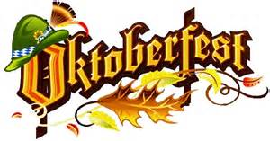
THE HOSPITALITY COMMITTEE OF HOLY MARTYRS OF JAPAN INVITES YOU TO…

OCTOBER 22, 2016
Holy Martyrs Parish Hall, doors open at 6:00pm Schnitzel and Oktoberfest sausage for dinner $15.00/person, $10.00/child (12 & under) and children under 5 years of age are FREE. Entertainment will be provided by Acclamation Nation. This event is presented by the Youth Ministry. Please come and support our parish youth!

