Support Groups are available now in Barrie, Bradford, Orillia and Midland with plans for support groups in local communities across Simcoe County.
Support groups can provide a safe and confidential environment where grandparents can create relationships with others who understand and have lived experiences in similar situations. Grandparents can build on skills, resource share and network to build a community of support.
GRANDPARENTS PARENTING AGAIN SUPPORT GROUPS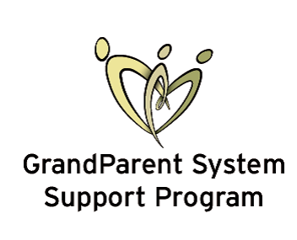
BARRIE Support Groups:
Barrie Native Friendship Centre  - Where:  175 Bayfield St.  - When: 2nd and 4th Wednesday of each month  - Time: 9:30am to 11:30am | Innisfil Best Start Child and Family Services  - Where:  218 Sunnybrae Ave, Stroud ON, L9S1H9  - When: to be determinated  - Time 9:30am to 11:00am | Ontario Early Years Centre  - Where: 129 Ferris Ln.  - When: 2nd Saturday of each month  - Time: 9:00am to 11:00am
Surrounding Area Support Groups:
ORILLIA  Ontario Early Years Centre  - Where: 80 Colbourne St. W., Orillia)  - When: 2nd and 4th Tuesday of each month  - Time: 1:30pm to 3:30pm | MIDLAND  Ontario Early Years Centre  - Where: 356 King St., Midland  - When: 1st Tuesday of each month  - Time: 1:30pm to 3:30pm | BRADFORD  Ontario Early Years Centre  - Where: 118 Barrie St.  - When: 1st and 3rd Wednesday of each month  - Time: 9:30am to 11:30am
** Childminding and transportation assistance may be available. If you experience any barriers to attending, please contact the Grandparent System Support Navigator at 705-726-9082 x2321

Supported By: 