News from Holy Martyrs of Japan – December
EDGE NIGHT!!!! Tell Your Friends!!! Our Parish invites our youth (grades 6-8) to join in on Mondays at 7:00pm to 8:30pm in the Parish Hall for Edge Night! Bring your friends! ALL ARE WELCOME!
November 21 – EDGE Survivor
November 28 – For the Love of God
December 5 – With the Eyes of Christ – A Night on Self Image
December 12 – A Door to My Heart – Visiting the Sick
December 19 – Christmas Social – Bowling

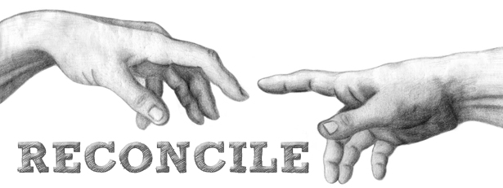
PARISH ADVENT RECONCILIATION
“Create in me a clean heart, O God and put a new and right spirit within me.” Psalm 51:10

Monday December 5, 2016 at 7:30pm for our Portuguese Community, Confessions will be heard this day in Portuguese.
We will be celebrating the Sacrament of Reconciliation on Thursday December 15, 2016 at 7:00pm. Multilingual priests will be made available to hear confessions in various languages. Come prepare your heart and make there room for the coming of our Saviour.
ARCHDIOCESE DAY OF CONFESSION
The Archdiocese of Toronto has announced the days of confession. Confessions can be heard throughout the churches of the Diocese of Toronto. Times may vary. Holy Martyrs will be offering confession on Friday December 16, 2016 between 12-2:00pm and 5-7pm.
_____________________________________________________________________________________
Advent/Christmas Church Events
December 17, 2016 6:30pm-Tree Blessing Ceremony followed by Caroling and Hot Chocolate
December 24, 2016 – CHRISTMAS EVE – 6:00pm, 8:00pm, and 12 Midnight, 9:30pm Spanish Mass
December 25, 2016 – CHRISTMAS DAY - Mass Schedule 8:30am, 10:00am and11:30am

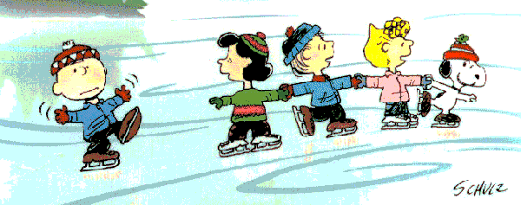
Holy Martyrs Family Skate Event – FREE FOR ALL
January 7, 2017 From 11:30am - 12:30pm
BWG Leisure Center – Green Arena

